Homeowner Name: Res No

Property Address:
Almaty International Airport (ALA has initiated a Noise Insulation Programme as part of its comprehensive Noise Management Plan developed by Frekans Acoustics. This programme is grounded in technical environmental noise studies and adheres to international standards and guidelines, including those set by the World Bank Group, IFC, WHO, ICAO, and the EU Balanced Approach Regulation. The central focus of the programme is to address and mitigate the impact of aircraft noise on buildings that are subject to night-time environmental noise levels exceeding 60 dBA with a target noise level of at least 40dBA and a minimum 5dBA reduction in interior areas during night hours., ensuring a reduction in noise exposure for the surrounding communities.
The goal of the program is to make it easier for the highest impacted homeowners surrounding ALA to talk on the phone, watch TV, listen to music, sleep, or have a conversation in their own homes. By properly sound-insulating these homes, homeowners not only gain a quieter interior, but may also benefit from long-lasting improvements and increased efficiency in their heating and cooling systems. Should your home become eligible for the program, you will receive a letter from the ALA inviting you to an informational briefing.
Noise Insulation Program Application

You will need to complete the following before your Virtual Visit
Further instructions to follow
1. Fill out a questionnaire about your home.
2. Provide technical passport with basic floor plan of your home and windows and doors measurements
3. Return completed questionnaire, floor plan and measurements to the CLO.

- Please fill out this questionnaire so that we can gather basic information about your home.

GENERAL
G1 | Do you have floor plans for your home?  - If so, please send a copy or photographs to your QHP Project Coordinator. | Yes | No
G2a | Have you built any room additions, or made any alterations to your property? | Yes | No
G2b | - If so did you obtain a building permit, what is the status of the permit?
G2c | - What is the date of the permit and the date that the alterations were completed
G3 | If possible, would you like to keep your front door? | Yes | No
G4 | Does your property have an attached garage? | Yes | No
G5 | Do you currently have a security system installed on your doors or windows? | Yes | No
G6a | Does your home have an attic space? | Yes | No
G6b | - If so, how is the attic accessed? (Access panel, pull down stair, etc.)
G6c | - What is the size of the access? (ie: 30” by 30”)
G6d | - What is the height of the attic space at its highest point?
G6e | - Does the attic cover the entire footprint of your house?
G7a | Does your home have a basement or crawlspace under the house? | Yes | No
G7b | - If so, how is the basement or crawlspace accessed? (Access panel, trap door, etc.)
G7c | - What is the size of the access?
G7d | - What is the height of the basement or crawlspace at its highest point?
G7e | - Does the basement or crawlspace cover the entire footprint of the house?

WINDOWS
W1 | How many total windows do you have in your home? | Total # of Windows
W2 | What types of windows are installed in your home? (Check all that apply)  Awning/Hopper Casement Fixed  Hung Jalousie Skylight | Garden Slider/Glider
W3a | Do you have any custom/specialty windows in your home, such as special shapes or leaded glass? | Yes | NNoo
W3b | If so, please briefly describe:
W4 | What materials are the windows in your home made from? (Check all that apply)  Aluminum Steel Vinyl | Wood
W5 | Is there anything else you would like us to know about the windows in your home?

DOORS
D1 | How many total exterior doors do you have in your home? |  | Total # of Doors
D2 | What types of doors are installed in your home? (Check all that apply)
 | Flush Door Decorative Panel Door French Door |  | Sliding Glass Door
D3a | Do any of your doors have specialty treatments such as custom panels or a “peek hole”? |  | Yes | No
D3b | If so, please briefly describe:
D4 | What materials are the doors in your home made from? (Check all that apply)  Aluminum Steel Vinyl |  | Wood
D5 | Is there anything else you would like us to know about the doors in your home?

MECHANICAL
1 | Do you currently have a central air conditioning system installed in your home?  (Note: Portable, window mounted, or through‐wall AC units do not apply) | Yes | No
2 | Are you interested in receiving an air conditioning or ventilation system if possible? | Yes | No
3 | What is the primary heating system currently installed in your home?
4 | - Where is your primary heating system currently located?
5 | - Is your primary heating system fully operational and in working condition?
6 | If you have any additional or secondary heating systems installed in your home, please list them below:
7 | What type of water heater do you have in your home?
 | - Where is your water heater located? (ie: indoor closet, exterior closet, etc.)
8 | Do you have smoke detectors installed in each sleeping room on each living level?
 | - If so, are they “hard-wired” or battery operated?
 | Is there anything else you would like us to know about the mechanical systems in your home?
ELECTRICAL
1 | Where in your residence is your electrical meter located?
2 | Generally speaking, what condition is your existing electrical meter in?
3 | If you know the capacity of your existing meter, what is it?
4 | Do you have any electrical sub-panels in your home? | Yes | No
5 | If so, where is your electrical sub-panel located?
6 | Please indicate major electrical appliances in your home (Check all that apply)  Electric Range/Oven Electric Clothes Dryer Vehicle Charger Other:
7 | Is there anything else you would like s to know about the electrical systems in your home?

FLOOR PLAN
If you have floor plans, please ensure your QHP Project Coordinator has copies. If not, please create a rough sketch of the floor plan of your home. You can draw on paper and take a photo to send to your QHP Project Coordinator. This drawing does not need to be to scale but should help the design team identify the different areas within your home.

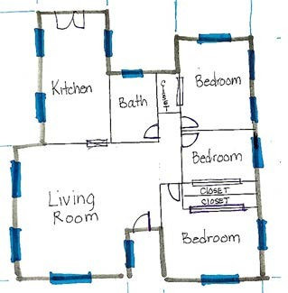
Floor Plan Notes & Tips:
  - Start by drawing the exterior walls of your home.
  - Sketch interior walls by starting from one corner of the room and working clockwise.
  - Label each room and provide interior dimensions.
  - Mark all interior doors and windows.
  - Show any stairs, openings, and major casework such as countertops or in-built cabinets.

TIP: Start drawing your floor plan in pencil, and finalize in pen once all measurements are done

TIP: Using graph paper to draw your floor plan can be helpful in keeping things aligned, but is not required

Measuring Windows and Doors Please measure your windows and doors prior to your virtual assessment. The design team can walk you through it during the virtual assessment visit if you have questions. Windows and Doors require three measurements each. We
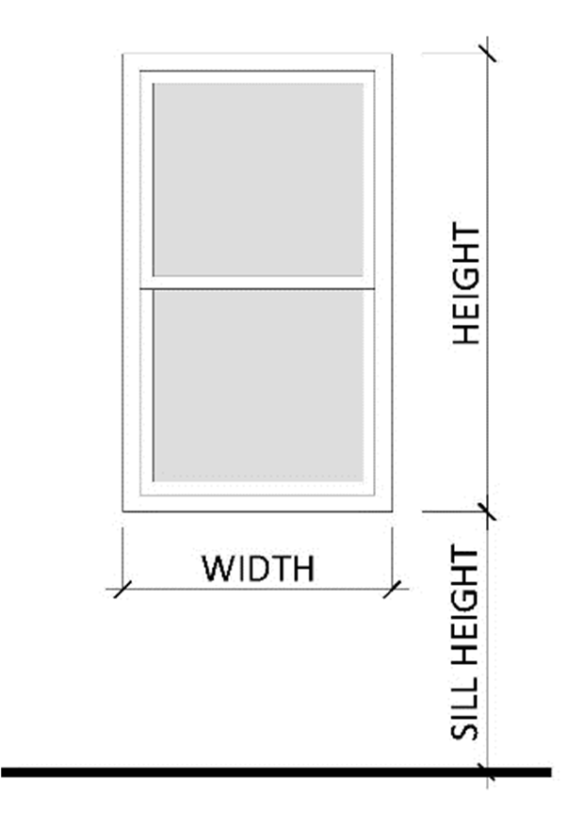
have provided blank window and door schedules for your convenience.
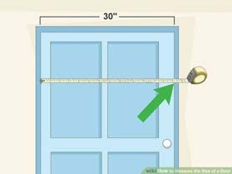
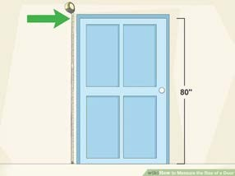
Door/Window Width Door/Window Height

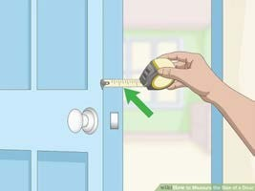
Required Window Dimensions
Thickness (Doors Only)

WINDOW SCHEDULE
EXISTING WINDOW
# | WIDTH | HEIGHT | SILL HEIGHT
1
2
3
4
5

DOOR SCHEDULE
EXISTING DOOR
# | WIDTH | HEIGHT | DOOR THICKNESS
A
B
C
D
E

